Operational Compliance within New Zealand Automotive Workshops

Abstract:

This paper explains how data gathered by third year undergraduate automotive students, revealed weaknesses in compliance issues within automotive businesses. Over a two year period, four cohorts of students examined a range of workshops - focusing on how these businesses conducted their activities in accordance with relevant New Zealand legislation. Supervision of students consisted of weekly meetings when they were reminded about the details of the main regulatory areas they needed to take into account when observing workshop practice. The supervisor also detailed the ethical procedures needed and stressed that they were not to inquire about economic aspects of the businesses, nor to report on it if they did receive such information. Data collection methods by students included New Zealand Government websites, as well as visual observations and photographs, and interviews with key staff within garages.

Data used for meta-analysis by the supervisor was only from the top students' reports, in order to eliminate rogue data. This revealed that the numbers of compliance failures were appearing on such a regular basis that it became essential that these findings should be brought to the attention of the automotive industry and its regulators. The paper concludes with recommendations for compliance improvements.

Key words: Workshop compliance; automotive education and training

Introduction

Over the course of the next decade, the transport sector is expected to be a major force behind the growing world demand for the movement of people and goods, the largest source of air pollution alongside industry (United Nations, 2006) ;:and a profuse producer of greenhouse gasses that lead to climate change. Transport is the largest end­ use of energy in developed countries, and the fastest growing energy-dependent sector in most developing countries.

As the sector grows, demand for vehicle servicing will therefore expand and this in turn will lead to the need for increased numbers of trained manpower. However, the current lack of knowledge and disregard of legislation and regulation in the industry have degenerated into a degraded and disorganised support for the ever more important transport industry which can only be rectified through focused training and education.

For this reason it is vital that compliance with relevant legislation is incorporated into trainee education and students' critical skills are honed to recognise non-compliance in their journey to become practitioners. This also allows them to integrate real world practices into their learning and observe the challenges of industry in a workshop environment.

The main areas of legislation relevant to this study at both national and regional level are:

- Health and Safety Legislation: The Health and Safety Employment Act, (1992} and the Health and Safety at Work Act (2015),
- Labour laws: Employment Relations Act (2000),
- Environmental protection: The Waste Management Act (2008) and the Resource Management Act (1991).

Theoretical Background of Compliance

There are two main theoretical bases to the arguments provided in this paper. One is the series of legislative issues, previously listed in the introduction, and the second is the question of compliance with that same legislation.

Research has shown that there are two basic incentives that encourage compliance: firstly, there is the economic argument (Becker, 1968) which asserts that people obey the law once legal sanctions raise the expected costs of non-compliance beyond expected benefits - otherwise known as the 'stick approach'. The second viewpoint, held mainly by sociologists and political scientists is that compliance is higher when people perceive laws to be legitimate and beneficial to them personally (Friedman, 2005) -the 'carrot approach'. McAdams and Nadler (2008) suggest that laws in themselves draw attention to the behaviours they are designed to promote, and once the participants have come to consider these requirements and their underlying purposes, they will tend to have a stronger motive to comply.

When the issue of automotive workshop compliance is examined, it will be seen that a combination of these motives are likely to be in operation.

Methodology

This research has been compiled from information gathered by third-year students during their studies to meet the requirements of the Automotive Professional Practice course within the Bachelor of Applied Technology, at Unitec Institute of Technology.
Four cohorts of second year undergraduate students undertook the investigation during a semester-long course designed to deepen their understanding of professional practice within the automotive industry. During the five weeks while pairs of students visited workshops, observing and recording operational procedures and occasionally asking questions of workshop personnel, they relayed their progress back to their supervisors on a weekly basis. At the end of this time, as part of their assessment requirements for this course, students were required to produce reports, based on their joint research, which was worth 35% of their overall course grade. Once that final report was written, students were interviewed singly by their supervisor to determine the extent of their individual participation in the joint inquiries and the understanding possessed by each of the individuals. Their summative grade for this report was potentially modified by information arising from this interview.

In the later analysis of the students’ findings by the academic staff member, all of the reports were examined from a total of 109 students but only those whose report scored 30 out of 35 (i.e. 86% or above) were ultimately used to consider issues of documented workshop compliance. This process was designed to eliminate the weaker students whose results might have been less reliable, thus reducing the limitations surrounding the use of students as data gatherers. This had the effect that although pairs of students prepared each report, as the final grading process could increase or reduce their individual results; the work of some lower-performing students within a pair was not taken into account. In the final analysis 26 out of 109 of reports were examined as indicated in Table 1.

Before the students formed themselves into pairs they had three collective sessions with their supervisor who initially reminded the students about the details of the main regulatory areas they needed to take into account when observing workshop practice.
Table 1: Source of student reports
Semester | Overall Number of students | Overall number of reports examined
1 - 2011 | 22 (11 pairs) | 1
2 - 2011 | 25 (12 pairs) | 10
1- 2012 | 29 (14 pairs +1) | 8
2 - 2012 | 33 (16 pairs +1) | 7

These were: Health and Safety Legislation, Waste Management, Customer Care and Workshop Practices. These issues brought together legal requirements, published in relevant New Zealand government Acts, which the students were recommended to examine with reference to its theory, main principles and base their observations on these key issues.

In addition to emphasizing the nature of observations they would be making, the supervisor also detailed the ethical procedures they would need to comply with, including verifying the preparation of information sheets and consent forms by the students themselves. In relation to this, he stressed that they were not to inquire about economic aspects of the businesses they visited, and not to report on it if they did incidentally receive information about workshops’ financial aspects. Lastly, he instructed the students not to select workshops where they might have been employed in the past, in order to reduce bias or conflict of interests.

At the end of this introductory stage the students formed themselves into pairs and made contact with garages in the areas where they could access conveniently. Four types of automotive businesses were selected by the students and from those finally selected for analysis the types were: twenty general automotive service centers; four Paint and Panel beating workshops, one Tire replacement workshop and one Warrant of Fitness Centre. This range ensured that diverse aspects of compliance became highlighted in the different sites. In most cases both students visited the same premises either singly or with one another to make their observations but in one case, the team decided to compare practices and visited two businesses and wrote their report combining their findings.

The staff member’s meta-analysis ultimately became focused on issues of legal non-compliance as the observations made by many of the students suggested that a range of activities of outstanding danger to both the public and to workshop personnel were taking place across a number of locations. Furthermore, he was so perturbed by these findings that he believed it was essential that these results be publicized to audiences who had an overview of automotive practices, such as the New Zealand Motor Trade Association (MTA) and the New Zealand Motor Industry Training Organisation (MITO).

As part of their observations, specific enquiries and interviews with key personnel were conducted to ascertain workplace compliance with relevant government regulatory directives as well as their operational activities and requirements. In order to eliminate dubious findings, all the reports were examined from a total of 109 students and only those who scored 30 (or above) out of 35 were used in this study. The findings and conclusions were then determined by the author of this paper.

The students examined a range of automotive related businesses, such as workshops and paint shops to see the extent that they conducted their business in accordance to specific New Zealand legislation and regulations. The students used three methods to collect data and detailed factual and evidential information to corroborate and create their reports. These were:

- New Zealand and Local Government websites to obtain detailed legislative regulations.
- Photographs to validate visual observations and written statements.
- Formal interviews with key staff members from companies to support and clarify observations.

Compliance Findings

In order to develop a logical sequence for their investigation of compliance in the three different fields mentioned above, students used a business flow model to acquire information about events namely: work-planning and work allocation, health and safety and waste management.

Health and Safety Compliance

The following cases demonstrate examples of compliance issues, which were found in 90% of the workshops visited.

Customer I Visitor Safety

In Figure 1, the company's reception is located in the middle of the workshop. Customers or visitors can only access the reception through the main entrances. They have to walk across approximately half of the distance across the working area of the workshop floor area until they can get to the reception. Due to this workshop layout, anybody can enter the workshop and any working area at will. This situation, which was common in student reports, illustrates a major area of non-compliance with the Health and Safety in Employment Act (1992).

Under section 16 of this Act, people who control workplaces, have a simple duty to warn visitors who have permission to be on their properties of any work-related, out­ of-the-ordinary hazards that they know about that may cause serious harm. This applies to business customers. In the above situation, the manager and employees are responsible for the safety of their customers which is compromised in this layout. The visits and observations made by the students enabled them to appreciate the responsibilities of workshops to their customers under the Health and Safety legislation.

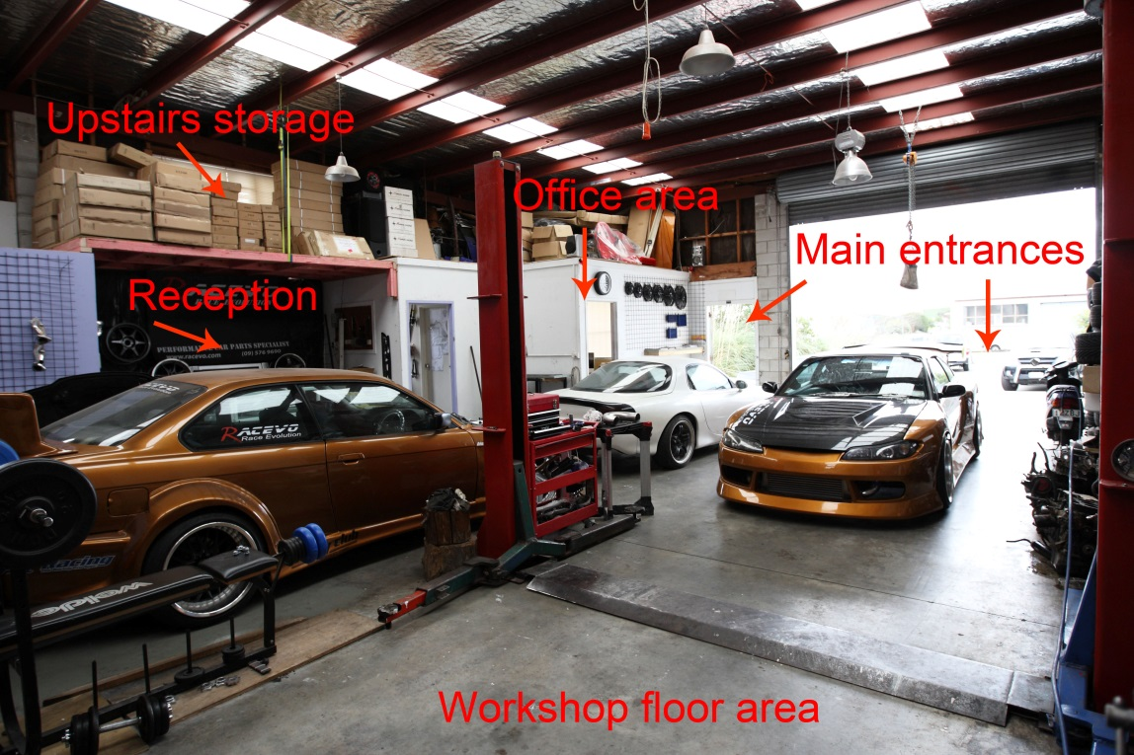

Figure 1: A workshop showing location of reception in relation to entrance.

Employee Safety

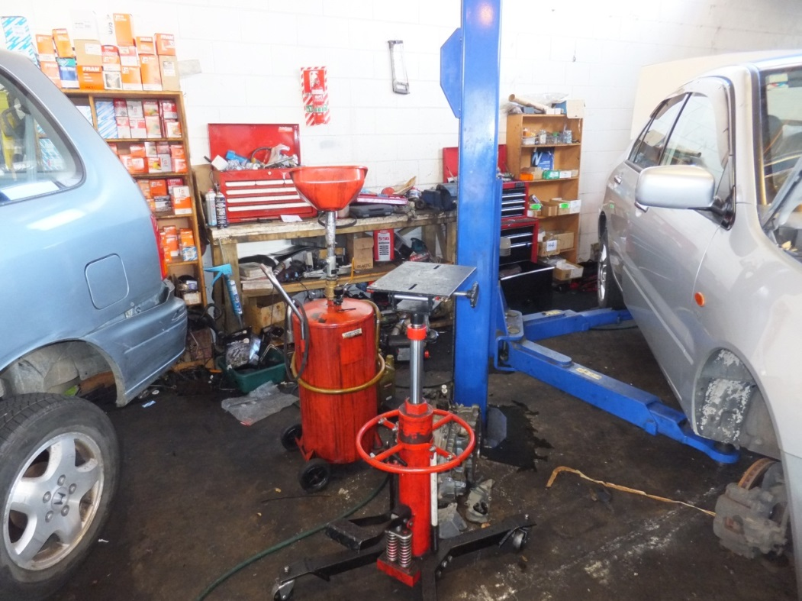
The emphasis of the Health and Safety Employment Act (1992) is on the systematic management of health and safety at work. It requires employers and others to maintain safe working environments, and implement sound practice. It recognizes that successful health and safety management is best achieved through good faith co-operation in the place of work and, in particular, through the input of those doing the work. Students recorded six workshops with serious contraventions of safety standards, some of which can be seen in Figure 2.

Figure 2: A workshop showing unsafe practices.
Figure 2 shows a systemic failure of the management to promote good practice and the failure of the workers to insist on a safe working environment. Examples of these failures are: slippery floor with spills, equipment placed in a haphazard and dangerous manner, and components on the floor which can cause workers to trip. The employees are contravening the Health and Safety Act which states that:

An employee's main responsibility is to keep one self and others safe. An employee must adhere to all procedures and processes the employer has in place to effectively manage the work environment and to wear protective clothing and equipment where necessary. It is a/so a requirement that an employee communicates any safety concerns to the employer and if the employee has any genuine concerns for their immediate safety they have a right to refuse unsafe work (Health and Safety Act, 1992, Section 10).

Figure 2 also indicates a lack of compliance with the Fire Safety and Evacuation of Buildings Regulations (2006) in that the spillage constitutes a fire hazard and the disorganized equipment would hinder evacuation in case of a fire. The students also reported issues such as: The workshop floor is covered with grit, containers of fluid are spread over a number of areas and raised up vehicles not supported by jack stands. Another major area of health concern was instances when compressed air was used to clean wheel assembles during servicing. This common practice creates a dust storm of particulate matter which is hazardous to anyone exposed to this environment.

Inhalation of toxic components was also found in several of the Paint shops visited by students where the painting areas were not ventilated sufficiently, thereby putting employees in considerable danger of inhaling toxic fumes.

Workshop illumination raises yet another issue of prime concern (David, 1993). Excellent automotive workshop illumination should be a major safety consideration for every workplace, regardless of its size. Inadequate lighting causes frustrations for Technicians and reduces productivity and quality of work, the students reported.

Students' findings also showed that work areas with poor lighting caused frustration during repair work, and also increase the likelihood of injury from colliding and scraping against hard metal or tripping over components. Three workshops inspected had poor lighting and use of natural light was hardly a feature of the workshop premises.

Waste Control

Solid waste disposal can be expensive and businesses able to reduce the volume of solid waste sent to landfill enjoy considerable cost benefits (Department of Environment and Climate Change, SW, 2008): Automotive Service and repairs workshops produce unserviceable electrical and electronic waste, tyres, used metal parts and batteries which pose a significant threat to the environment when disposed of incorrectly. The surveyed workshops showed a mixed practice of sustainable compliance in waste management. Some workshops have adapted good sustainable practices, while other workshops were found to be leaning towards to gross negligence. Examples of this were oil seeping into storm water drainage system, tyres left exposed to the weather, developing breeding ground for mosquitoes and recyclable components were put in landfill collections. The major regulators of waste management issues are established by local councils. For example: Vision set by the Tauranga City Council states 'Sustainable waste management that protects the environment for present and future generations by vigorously promoting waste minimisation to achieve a zero waste target by 2015. New Zealand has a number of waste removal companies. These companies are setup with the business concepts to solve waste reduction, reuse and recycling which is a major social problem in the post-modern era. Our degree of dependency on technology and their life cycle makes us vulnerable and society needs to have deep commitment to sustainable practices.

The Auckland City Council has adopted a Waste Management Plan (2012).that has three main drivers:

- The Legislative requirement that "a territorial authority must promote effective and efficient waste management and minimisation within its district (Waste Management Act 2008, p.30).
- The Legislative need to review the seven former local authority's waste plans and the obvious desirability of forming one cohesive consistent waste management and minimisation plan for the region.
- The council's adoption of and inspirational goal of zero waste by 2040.

The Auckland City Council plan focus is biased towards household waste as these are more visible; however waste from the motor industry is not of the highest priority. Business houses must ensure that non-biodegradable waste are recovered and recycled, or disposed of correctly. Collection and consolidation methods could significantly reduce waste going to landfill.

Work Planning and Work Allocation

Several students noted that there were inefficiencies in workshop planning, such as delays in ordering replacement parts once a vehicle had been dismantled. They saw that this resulted in poor workplace utilisation with the dismantled parts occupying the floor area which in turn lead to Health and Safety issues. Delays of this nature required the workshop to provide customers with courtesy vehicles, all of which contributed to lower profitability.

According to the relevant employment agreement, working hours are based on the needs of the business and are stipulated in the employment contract. Most organisations pay time and a half when employees work during public holidays and hours outside the stipulated hours in the employment contract.

The students began to realise that delays due to unplanned work would also increase the cost to the workshop in terms of overtime for its staff.

Automotive business organisations operate during normal operating hours e.g.: Monday to Friday from 8.00 am to 5.00 pm, Saturdays from 8.00 am to 12.00 pm. There are some business organisations such as spare parts that do provide services beyond the above time and also provide services on Sundays. Students reported that most business organisations that they visited not only met the minimum requirements but exceeded it as per the Employment Relations Act (2013).

Discussion

Many of the compliance failures observed can be correlated with two issues: ignorance of the legal requirements by workshop management and the socio­ economic location of the business. Up-market vehicle service centers strive to maintain the cleanliness of the workshop indoors and outdoors as well. When entering these premises it is easy to see the tidiness of the workshop by the display of the methodical way that all the vehicles are placed. It is difficult to fault these businesses in many aspects especially in terms of cleanliness and being environmentally concerned. A business attuned to the principles of good sustainable practices therefore makes the reduction of hazards as the first order of business. This in some cases are kick started by making the employees sharing as much information as possible about possible hazardous activities and discussing the implications of non-action by those in practice. Once there is acknowledgement, it goes a long way towards ameliorating the threats of hazards.

In individual small operations, especially when it is owner operated, Health and Safety takes second priority to the profitability of the business. As these are mostly small owner operated business, the focus is short term, more on trying to make a living profit then complying with statuary or social responsibilities. This exercise allowed students to become aware of the hazards potentially present in workplaces and prepared them to become more professional.

Both employer and employee under the Health and Safety Act, 1992, share responsibility in reporting any accidents that may occur within the work environment and if serious harm has been a result, the Labour Department will carry out a thorough investigation to establish the cause and if gross negligence is found to be a contributing factor, prosecution under the Act is possible.

Waste management practices as observed were dependent on the socio-economic location of the workshops. It was evident that workshops that are operating in higher socio-economic areas were more responsive to being and promoting good business citizens while those operating the lower socio-economic areas paid less attention to environmental issues. The observations and comments made by the students who had visited workshops, particularly those with failures in the waste management area, indicated that this industry-based experiential learning also had a significant impact on their understanding of the need for this subject to be taken seriously.

Conclusion

Of the thirty five samples surveyed and analysed, Health and Safety practices in the Automotive Service and Repairs in Auckland are varied and dependent on the size of the business, the socio economic location and being owner operated or part of franchised dealerships. Companies with high profiles comply and in some cases exceed their obligation with any of New Zealand's central and local government legislative requirements. Smaller owner operated companies especially those operating in the lower socio-economic areas tended to ignore basic social and moral responsibilities and tend not to comply with their legislative requirements. Reasons for non-compliance can be attributed to lack of legislative requirements, poor compliance inspection by authorities and uneconomical business operations. Considering the reasons stated earlier for potential lack of compliance, it may well be that the economic 'stick' works strongly with the managers of workshops while the 'carrot' approach has a greater influence with the workforce.

The promotion of good business citizenship schemes would ensure businesses undertake Health and Safety as part of daily practice and not see it as a compliance requirement. Poor Health and Safety practices runs the risk of prosecutions and fines, harmful effect on the health and safety of employees, damage to the business reputation and in an event of a major disaster and expensive clean-up cost. Research has proven that businesses that manage risks and have embedded good practices have the advantage of opportunities that will improve efficiency and profits.

Revisions to the Health and Safety Act- due to be operational in April2015, are designed to reduce workplace accidents and injuries. The changes in the new legislation are planned to address major hazard areas such as hazardous substances and occupational health with increased resourcing to enforce compliance and the encouragement of worker participation. The new Act will require workshops to meet higher levels of proof of compliance, to demonstrate planning to eliminate or minimise risk, and display a greater degree of focus on occupational health risk assessment and controls.

These goals will only be attained if the workforce at all levels is well trained and fully aware of their individual responsibilities. The awareness of Health and safety practices in automotive workshops by students will allow them to implement changes once they join employment in industry.

References

Auckland Waste Management and Minimisation Plan, 2012. Getting Auckland’s Waste Sorted. http://www.aucklandcouncil.govt.nz/EN/environmentwaste/rubbishrecycling/wastemanagementandminimisationplan/Documents/finalaucklandwastemanagementandminimisationplan.pdf

Becker, G. (1968). Crime and punishment: an economic approach. Journal of Political Economy. 76 (2). pp. 169-217.

David, H. J. J. (1993). How to Design and Build your Own Workshop. Osceola: MBI Publishing Company

Department of Environment and Climate Change, 2008. Environmental Action for Automotive Servicing and Repairs.
http://www.epa.nsw.gov.au/resources/clm/200877_Auto_ServiceRepair.pdf

Employment Relations Act, New Zealand Statutes. (2000).
http://www.legislation.govt.nz/act/public/2000/0024/latest/DLM58668.html

Fire Safety and Evacuation of Buildings Regulations, New Zealand Statutes. (2006).
http://www.legislation.govt.nz/regulation/public/2006/0123/latest/DLM382016.html

Friedman, L. M. (2005). Coming of Age: Law and Society Enters an Exclusive Club. 1st Annual Review of Law and Social Science. pp.1-16.

Health and Safety Act, New Zealand Statutes. (1992). http://legislation.govt.nz/act/public/1992/0096/latest/DLM279218.html?search=sw_096be8ed80d007f4_an+employees+main+responsibility_25_se&p=1

McAdams, R.H. & Nadler, J. (2008). Coordinating in the shadow of the law: Two contextualized tests of the focal point theory of legal compliance. Law and Society Review. 42 (4). Pp. 865-898.

United Nations (2006). Climate Change Overview. Department of Economic and Social Affairs. http://www.un.org/esa/desa/climatechange/transport.html

