Funding, participation and quality in VET

Abstract
The purpose of the paper is to present estimates of changes in the funding of VET and to consider the relationship of funding to participation and to quality.

The broad context for the study is Australian and state government commitment to the expansion of VET but at lower cost in a more competitive market with greater involvement of the private sector. Its focus is Australia in the last fifteen years

The paper presents funding data in real terms by discounting for price changes. It relates funding to information on participation and on quality. It draws on studies by academics and government agencies and uses recent Productivity Commission, NCVER, ABS and Australian Department of Education sources.

Conclusions include
- the long term decline in real funding per hour in VET has continued
- the VET sector fares badly compared with schools and higher education
- participation changes in part are due to funding changes
- quality changes in part are attributable to declining real funding per hour of training
- quality changes are associated with the expansion of funding to private for-profit providers without adequate assurance of their assessments

Introduction

This paper considers changes in VET funding and its relation to domestic student participation rates and to the quality of training. It does this by analysing data and studies from a range of government authorities and researchers. Attention is given to the quantity of funding but also to the extension of government funding to private providers, the removal of caps on the number of places, and changes in the charging of fees to domestic students. All of these matters may be associated with participation and with quality.

Background

The Australian National Training Authority (ANTA) agreement of 2002 between state and territories included setting up ANTA and an annual boost in funding from the Australian government from 1992 to 1997 with the states required to maintain their effort. When the growth funding stopped a new agreement used the phrase ‘Growth through efficiencies’ to require the states to continue to expand VET in return for the Commonwealth maintaining the funding at the 1997 level. In later years of the Howard government some schemes such as Australian Skills Vouchers program, which provided funding direct to public and private providers, boosted spending. A very large increase was made to Australian government funds in 2008 to 2010 through temporary capital grants, the Productivity Places Program, with payments direct to providers, and national agreements with state governments. But Australian government funds have fallen back a little in more recent years.

Some, but not all, Australian government grants to the states are adjusted for inflation. Since 1996 this adjustment has been at a rate well below the changes in the consumer price index (CPI) and even that tends to rise less than wage rates. Higher Education funding by the Australian government was adjusted in the same way as VET funds prior to 2012 but it is now to have its funding adjusted by CPI. There has been no change proposed for VET.

The aims of the first ANTA agreement included promoting:
- an effective training market, with public and private provision of both high level, advanced technical training and further education opportunities for the workforce and community generally
- an efficient and productive network of publicly funded providers that could compete effectively in the training market (Goozee 2001).

ANTA wanted to encourage competition to better satisfy the clients and to reduce costs of delivery. The most notable way this was done was ‘User Choice’ whereby employers could choose the Registered Training Organization (RTO) to deliver and assess the training of apprentices and trainees. The state then funded the public or private provider chosen. In some states there were restrictions on the extent to which private providers could be chosen.

Most Australian government funds are passed to the states to be allocated to providers though as mentioned some Australian government programs such as Skills Vouchers and Productivity Places bypassed the states and funded public and private providers directly.

Within the states there was some extension of the choice of public or private provider beyond User Choice but the major development was in Victoria with its introduction, fully implemented in 2011, of an open ended student entitlement system. Under this all students were entitled to a government supported place with some restrictions such as that the qualification sought should be at a higher level than already held. The students could choose a public or private provider. The new scheme led to a massive expansion in government funding, virtually all to private providers. Funding was reduced in 2013 by cutting the funding rates for many courses following the deregulation of fees (though maintaining additional subsidies for disadvantaged up to Certificate IV level).

The deregulation of fees in Victoria could be seen as the final reversal of a policy to abolish fees in tertiary education brought in by the Whitlam government in 1974. A small fee was introduced in higher education by the Commonwealth in 1987 but more substantial fees in 1989 along with HECS loans. In the VET sector fees have gradually been introduced. VET fees were at very low rates until recently with domestic student fees on average raising only about 5 per cent of total VET revenues.

Overall VET participation rates expanded in the 1990s, stagnated in the 2000s and expanded rapidly for a few years from 2009. The participation of equity groups tended to expand in the years of rapid overall expansion of student numbers

When VET was very largely provided by TAFE there was criticism of its responsiveness and relevance and to some degree of its cost. There was less criticism of the quality of the courses provided. Broader concerns about quality came to the fore with the rapid expansion of international students in VET very largely with private providers in the years to 2010. A key driver of the expansion was the almost automatic access that a range of courses gave to independent skilled migration and then to permanent residence. The tightening of migration rules led to a sharp fall in international students. For domestic students quality issues arose especially with the move to entitlement systems where most if not all the expansion was with private for-profit providers.

Method and data

The paper draws on a number of earlier studies and analyses (e.g. Burke 2015 a & b, Noonan et al 2014). For data on spending and participation the main sources are NCVER and the analyses made by the Productivity Commission. For quality there are a range of sources but in particular reports by the Productivity Commission.

For funding data the annual spending in current prices is converted to real values by discounting for price changes. The discounting method chosen can have a substantial effect on the estimates. The issues are discussed in detail in Burke and White (2003). The Productivity Commission uses the Chain Price Index of the GDP which in recent years has been particularly affected by changes in minerals prices. The Chain Price Index showed no increase in 2013 whereas the Consumer Price Index rose by over 2 per cent.

The consideration of funding concentrates on the funds for the delivery of training largely in publicly supported training. There are other elements of funding affecting VET students which can have particular effects on participation and quality. Some of these will be raised at the conference presentation. They include:
- income contingent loans to Diploma and higher level students
- the provision of Youth Allowance, Austudy and Abstudy for full time student who meet means tests
- the provision of incentives to employers of apprentices which are being restricted to areas identified as skill needs
- additional learning support for less advantaged persons
- provision of fee subsidies for the disadvantaged and policies on the regulation of fees
- the impact of funds from international students much of which is received by private providers

Findings and discussion

Funding

Figure 1 shows the total revenues of the Australian VET system as reported by NCVER. It includes the all the public and private revenues of public providers but only the public revenues of private providers. Overall there was virtually no growth in funding 2003 to 2008 but it was some 20 per cent higher by 2013

Commonwealth funds had jumped considerably in 2009 but fluctuated since. State funds had a remarkable surge in 2011 sustained in 2012 but falling in 2013. Victoria’s new entitlement scheme was largely responsible for the jump in state funds. Victorian government funding was over $600 million higher in 2012 than in 2010 an increase of 65 per cent. It was cut back by over $300 million in 2013.

Figure 2 shows the VET revenues for Australia minus Victoria. This confirms Victoria as the main area of expansion and it also indicates that Victoria receives relatively more from fees and charges than other states.

Figure 1. VET revenues, Australia, 2003 to 2013 $ million, 2013 prices
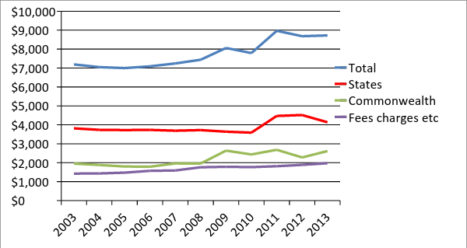
Source: Based on data from NCVER 2014a and ABS 2014
Figure 2. VET revenues, Australia minus Victoria, 2007 to 2013, ($ million) 2013 prices
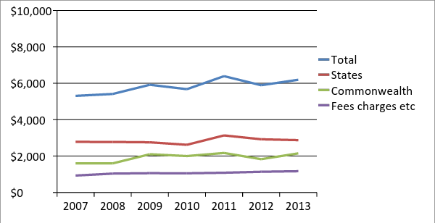
Source: NCVER 2014a

The funding for the VET system is allocated usually on hours of training delivered. Figure 3 concentrates on government funding. It shows the changes in funding per hour of government funded training delivered. The features of this are the very large decline in real funds per hour of training and the very large differences across the states. Whereas the rate per hour for Australia as a whole fell by 25 per cent from 2004 to 2013 it fell by 10 per cent in Queensland to 34 per cent in Victoria and over 40 per cent in South Australia
Figure 3. Government real recurrent expenditure per annual hour (2013 dollars)
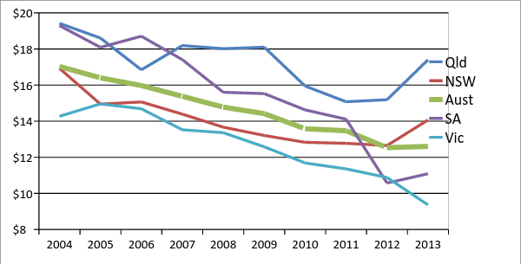
Source: Productivity Commission 2015
The total hours delivered can reflect an increase in students or an increase in hours of training per student. An increase in hours per student can be due to a lengthening of their course or their enrolment in multiple courses.

The numbers of VET students was at much the same level in 2009 as in 2003 but grew to be 10 per cent higher in 2013. The total hours of training delivered were some 50 per cent higher in 2013 than in 2003 with most of that growth in the last five years. The growth in hours was most substantial in Victoria.

To summarise, while total funding was some 20 per cent higher than in 2003 student numbers were some 10 per cent higher and hours of training 50 per cent higher.

Table 1 shows that the increase in hours per student largely occurred with private providers. The number of students in TAFE fell some 7 per cent 2009 to 2014 but the hours remained at 2009 levels implying a growth of about 7 per cent per student. For private providers the number of students increased about 100 per cent but the hours by 200 per cent implying a growth of nearly 50 per cent in hours per student.

Victoria and South Australia are well ahead of the other states in funding private providers. Figure 4 shows of the expansion for Australia of nearly $900 million from 2004 to 2013 over two thirds was in Victoria. In Victoria the proportion of government funds so allocated in 2013 was close to 50 per cent compared with a little fewer than 30 per cent in South Australia, about 7 per cent in NSW and an Australian average of a little under 25 per cent.

Table 1 Provider type by number of students and hours of delivery Australia, 2009–13 ('000)
 | 2009 |  | 2010 | 2011 | 2012 | 2013
Number of students
TAFE and other Gov’t |  | 1274 | 1299 | 1248 | 1258 | 1190
Index |  | 100 | 102 | 98 | 99 | 93
Other registered providers |  | 267 | 348 | 483 | 551 | 538
Index |  | 100 | 130 | 181 | 206 | 201
Number of hours of delivery
TAFE and other gov’t |  | 368291 | 375877 | 367500 | 381717 | 368527
Index |  | 100 | 102 | 100 | 104 | 100
Other registered providers |  | 52221 | 78399 | 126243 | 155222 | 153963
Index | 100 |  | 150 | 242 | 297 | 295
Source NCVER 2014b

Figure 4. Government recurrent payments to non-TAFE providers 2004 to 2014 Australia and Victoria 2013 dollars ($million)
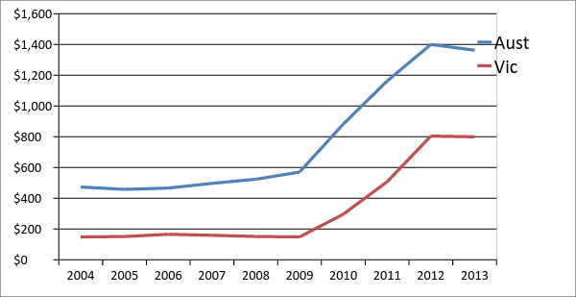

Funding of VET compared with schools and universities

The considerable fall in funding per hour of training delivered in VET was shown in Figure 3 above. This continues a decline over a longer period. Table 2 provides a comparison of the changing rates of public funding for VET in comparison to schools and universities from 1999 to 2011. The rate of funding for schools per student has increased considerably over time. For universities it has fluctuated.

Table 2 Indexes of government recurrent expenditure per full-time student (schools and higher education) and per hour of training (VET), Australia 1999 to 2011 (1999=100)
 | Government secondary schools | VET | Higher education
1999 | 100 | 100 | 100
2005 | 118 | 93 | 101
2011 | 120 | 75 | 103
Source: AWPA 2013

The Productivity Commission (2015, Table 4A12) provides more recent data on school funding. Government recurrent spending per student in government schools adjusted for price change was 14 per cent higher in 2012-13 than in 2003-4.

Participation

Changes in participation in VET over time are briefly outlined here. It can be noted that VET has much higher participation rates in all groups than higher education (Burke 2015).

As mentioned total VET students were stagnant in the years to 2009 but grew about 10 per cent 2009 to 2013. In keeping with this the Productivity Commission 2015 estimated government funded students were equal to 8.3 per cent of the population aged 15-64 in in 2004, 8.4 per cent in 2009 and 9.4 per cent in 2013.

The Productivity Commission was asked to report on participation in four equity groups:
- Aboriginal and Torres Strait Islander people
- people from remote and very remote areas
- people with disability
- people speaking a language other than English (LOTE) at home

Surprisingly, given its importance in analyses of equity in higher education and schools, the Productivity Commission was not asked to report on participation by socio-economic group.

The participation rate of the 15-64 aged Indigenous persons is much higher than for the non-Indigenous. This in part reflects the much younger average age of the Indigenous persons. The rate had increased from around 15 per cent in 2004 to 17 per cent in 2013 though it was little lower than in 2012 and 2013.

VET has had notably higher participation rates among persons from remote and very remote areas than in closer regional areas or the cities. However the data reported by the Productivity Commission (2015 Table 5A12) suggest a small falling away in the remote areas and that much of the recent lift in participation is in the cities.

Persons reporting a disability increased their proportion of publicly funded VET students by some 10 per cent in the years 2009 to 2014. Persons speaking a language other than English at home have a somewhat lower participation rate than persons speaking English. Their relative position may have improved slightly.

As mentioned the Productivity Commission does not report on participation by socioeconomic (SES) background. Data available from 2006 to 2011 show a constant proportion of VET students from the lowest SES quintile (NVEAC 2013). More recent data needs to be analysed on this.

Quality

In VET, funding constraints have been one of the factors leading to a reduction in face-to- face teaching and to casualisation of the workforce. The Productivity Commission (2011c) estimated that ‘about 60 per cent of trainers and assessors in TAFE, and 36 per cent in the non-TAFE sector, were employed on a non-permanent basis, compared to 25 per cent of the wider labour market’ in Australia.

As an aside, it is hard to see how the quality of teaching could have been sustained in Victoria with the very rapid expansion in 2011 and 2012.

The large majority of graduates from VET have expressed satisfaction with their courses and the work related benefits and this has changed little over time (NCVER 2013b). However there was a notable decline in employer satisfaction from 2011 to 2013. Employers agreeing that ‘vocational qualifications provide employees with the skills they require for the job’ decreased 6 percentage points to 78 per cent (NCVER 2013a).

Complaints about quality became prominent in the last decade with the rapid increase in numbers of international students in VET very largely enrolled in private for-profit training providers (Knight 2011). The increased provision of public funds to private providers for domestic students in VET has seen complaints about poor quality provision continue. The Productivity Commission has raised this in a number of reports, for example on training for aged care:

Unless existing concerns surrounding poor quality training are addressed, much of any increased investment in vocational education and training could be wasted (Productivity Commission 2011a)

In response the Australian Skills Quality Authority (ASQA) undertook a major review of training providers for aged care. A large majority were found to be initially non- compliant. Many programs were too short to enable students to become competent. There was a lack of assessment in a workplace and a failure to ensure valid assessment of essential skills and knowledge (ASQA 2013).

The OECD review of Australian VET (2008) argued for standardised assessment to ensure consistency. Skills Australia (2011) recommended that there be independent external validation of assessments and the trialling of this was included in National Partnership Agreement among the national and state governments (COAG 2012, AWPA 2013).

Market competition can be effective when there are sufficient numbers of buyers and sellers and good information. In VET as in higher education it is important that students and employers have good information on which to base choice of type and quality of course in relation to fees charged. The development of national websites such as My Skills will be important. However, given the difficulty particularly for young persons in assessing the quality of the offerings effective regulation of key aspects of quality such as assessment will remain essential.

Conclusions

Some key points presented in the paper are listed here followed by a brief discussion.

On funding:
- total funding was flat in the early years of this century, had a rapid increase for a few years from 2009 but may be level or falling now
- the long term decline in real funding per hour in VET has continued
- there are very large differences among the states in funding levels and provision to private providers
- part of the funding in recent years has been allocated for an increase in hours of training per student that has occurred with open-ended entitlements
- the VET sector fares badly compared with schools and higher education

On participation:
- overall participation rates rose in the years of increased funding and student numbers
- Indigenous students are well represented in VET and their rates of participation have increased a little, as have those for persons with a disability
- participation of persons from remote areas though high has relatively fallen
- persons from low socioeconomic status do not seem to have improved their share though in holding a share will benefit from expansion

The relationship of funding to quality seems obvious when it leads to larger classes, reduced hours of delivery and less qualified teachers. It is possible however that developments in online learning may enable quality to be delivered at reduced cost. Ongoing analysis is needed here.

Australia does not have fully independent validation of assessment leading to the award of a qualification. The introduction of open-ended funding of private providers before quality-assuring assessment procedures left the system open to fraudulent providers. Related to this, the rapid increase in hours per student enrolled with private providers may be associated with multiple enrolment but not necessarily a commensurate increase in training provision.

References
Australian Bureau of Statistics (ABS) 2014, 5204.0 Australian System of National Accounts.
Australian Skills Quality Authority (ASQA) 2013, Training for aged and community care in Australia, A national strategic review of registered training organisations offering aged and community care sector training, Melbourne.
Australian Workforce and Productivity Agency, (AWPA) 2013, Future Focus, 2013 National Workforce Development Strategy, Canberra.
Burke G, 2015a ‘Australia: Finance, Quality and Participation in Postsecondary Education’ in Education in Australia, New Zealand and the Pacific edited by Michael Crossley, Greg Hancock and Terra Sprague, Bloomsbury, pp 61-89.
Burke G, 2015b ‘Australia’s funding schemes in postsecondary education and disadvantaged students’, Journal of Educational Planning and Administration (New Delhi) XXIX No 1 January in press.
Council of Australian Governments (COAG) 2012, National Partnership Agreement on Skills Reform, Canberra.
Goozee G 2001, The Development of TAFE in Australia, NCVER Adelaide.
Knight M 2011, Strategic Review of the Student Visa Program 2011, DEEWR, Canberra.
Noonan P, Burke G, Wade A and Pilcher S 2014, Expenditure on education and training in Australia, Analysis and background paper, No. 01/2014 Mitchell Institute Victoria University
NCVER 2013a, Employers’ use and views of the VET system 2013, Adelaide.
NCVER 2013b, Student Outcomes Survey 2013, Adelaide.
NCVER 2014a, Financial Information, Adelaide.
NCVER2014b, Students and Courses, Adelaide.
National VET Equity Advisory Council (NVEAC) 2013, National Report on Social Equity in VET 2013, Melbourne.
Organisation for Economic Cooperation and Development (OECD) 2008, Learning for Jobs, OECD Reviews of Vocational Education and Training Australia, Paris.
Productivity Commission 2011a, Caring for older Australian, Melbourne.
Productivity Commission 2011b, Early Childhood Development Workforce, Melbourne.
Productivity Commission 2011c, Vocational Education and Training Workforce, Melbourne.
Productivity Commission 2015, Report on Government Services, Melbourne.
Skills Australia 2011, Skills for Prosperity, A Roadmap for Vocational Education and Training, Canberra.

